**Create and Manage a Nonrelational Database (DynamoDB)**

1. **Introduction**

**Setup CLoud9 IDE**

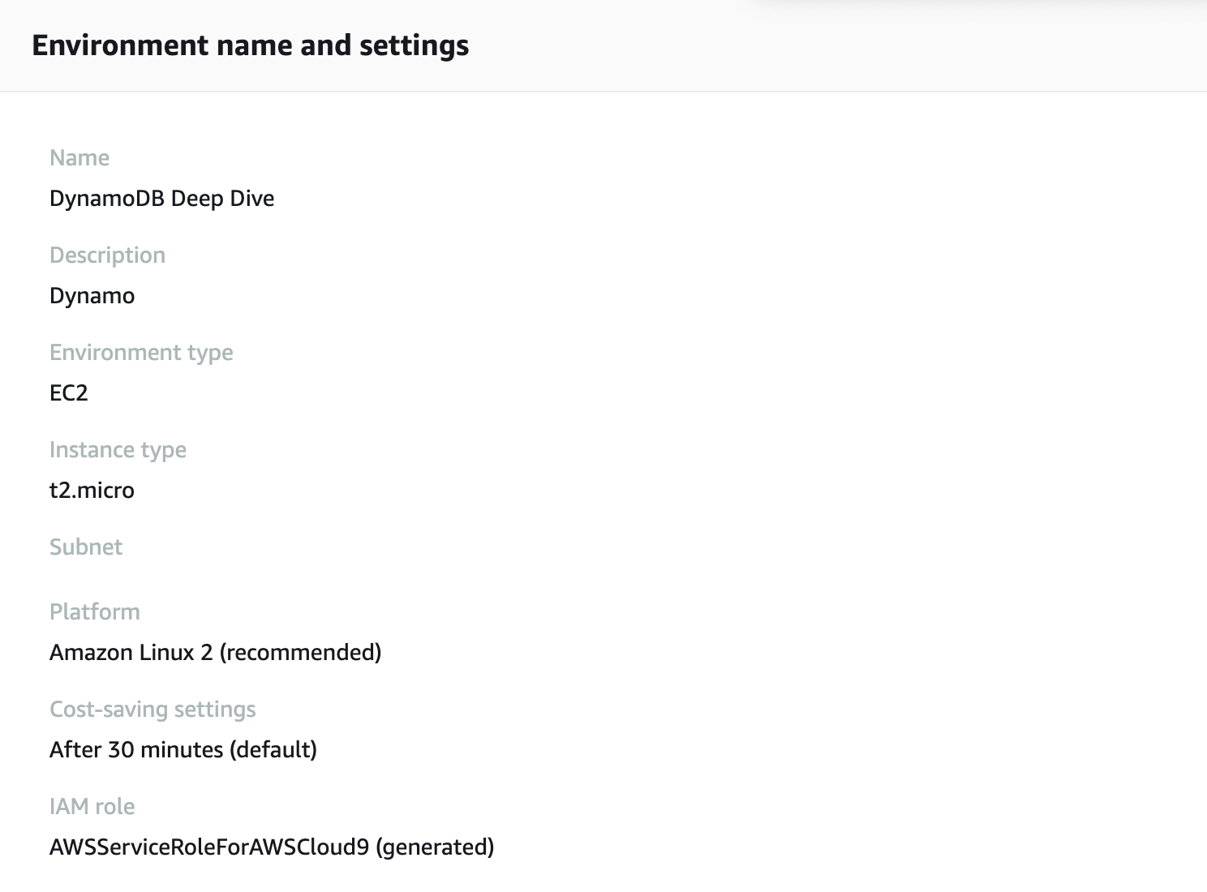

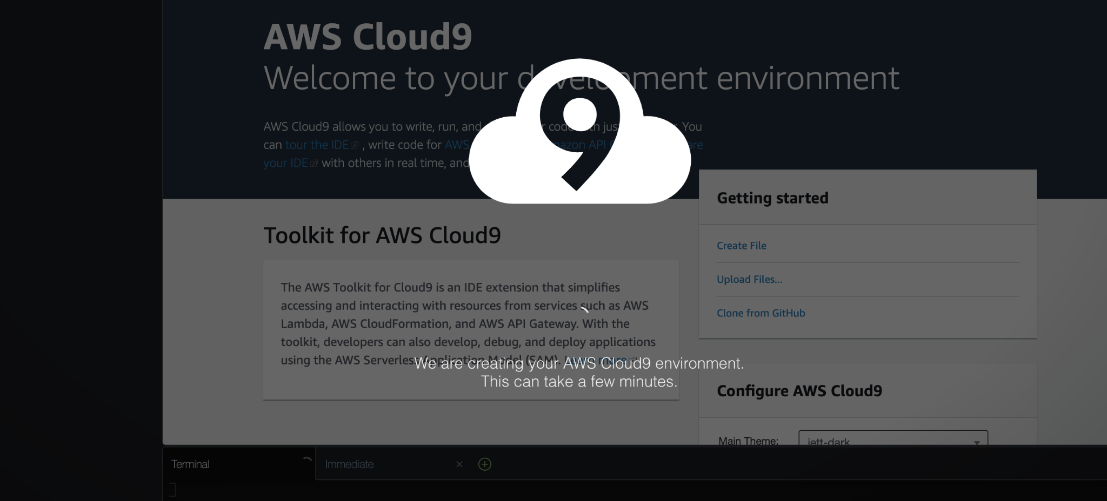

1. **Application background**

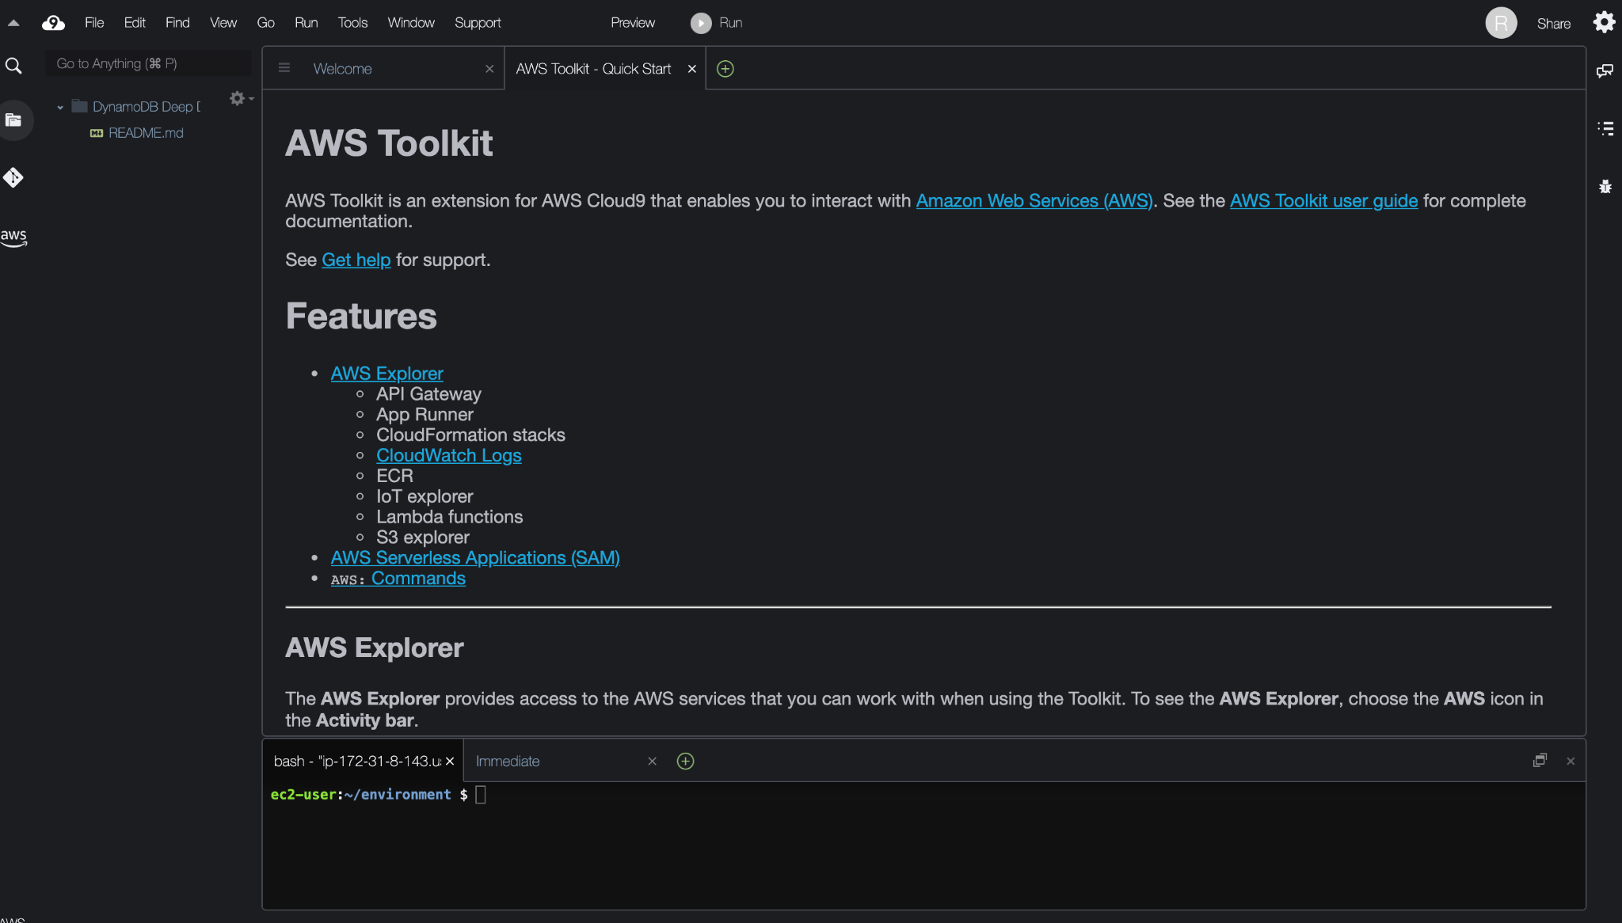

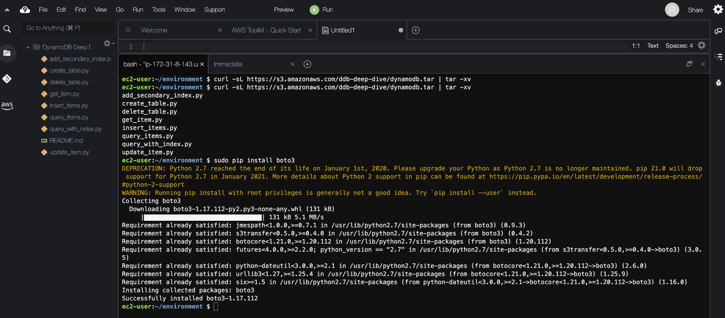

1. **Inserting and retrieving data**

**Create a Dynamo Table, Load Items into the table and Retrieve items from the table**



1. **Querying and global secondary indexes**

**Retrieve multiple items with a query**



**Creating secondary index**

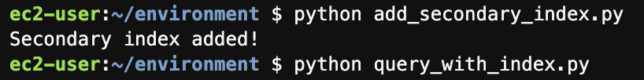

**Querying a secondary index**



1. **Updating items**

**Updating an item**

**Before Update**



**After Update**

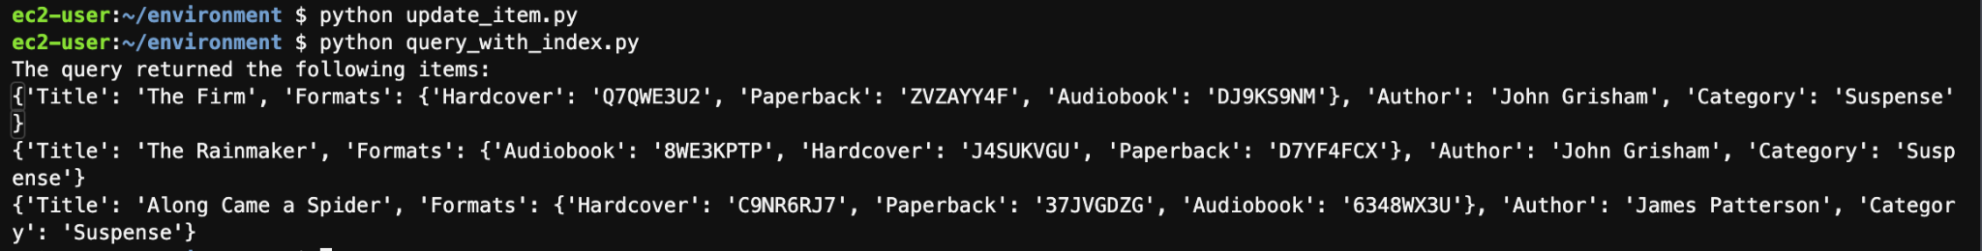

1. **Clean up and next steps**

**Delete your DynamoDB Table**



**Delete your AWS Cloud9 Environment**

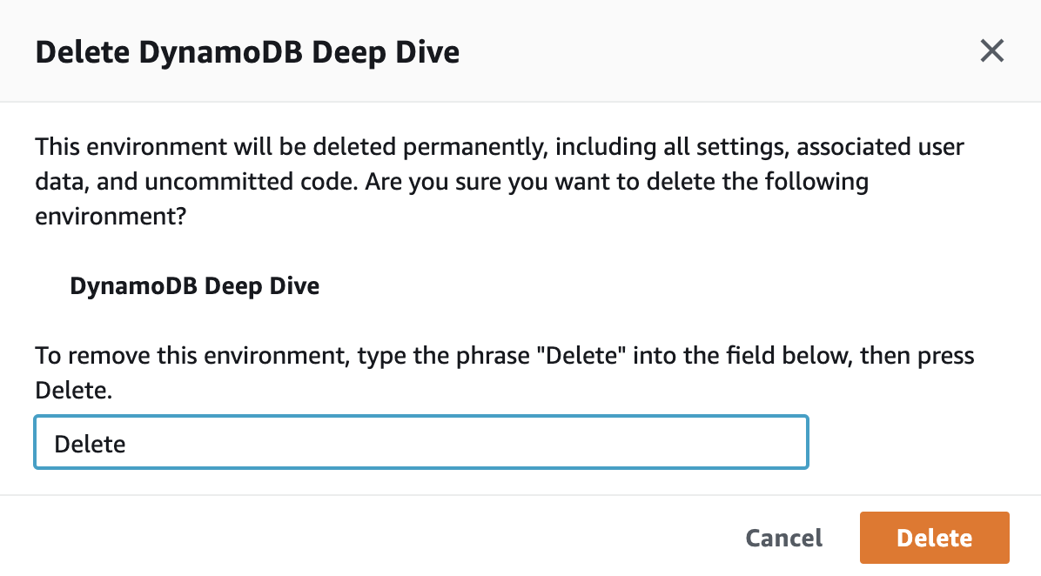

**Todo : Delete vpc for ohio ,and check other regions as well**